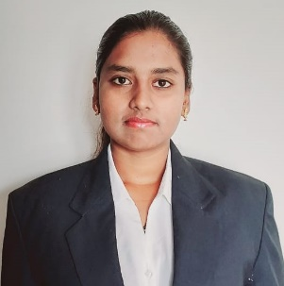**Name:** SANDHYA K

**Contact:** +919110612630

**Email Id:** [ksandhya15121999@gmail.com](mailto:ksandhya15121999@gmail.com)

|  |
| --- |
| Curriculum Vitae  CAREER OBJECTIVE |

To make establish a career as an Executive in a dynamic and progressive organization where my skills can contribute to the company’s goals and achievements and also aid my own personal and professional goal.

|  |
| --- |
| EDUCATION |

|  |  |  |  |  |
| --- | --- | --- | --- | --- |
| Qualification | Institution | University | Year of Passing | Percentage/  CGPA |
| MBA | REVA UNIVERSITY | REVA University | 2022 | Pursuing |
| B.com | MAHARANI LAKSHMI AMMANNI COLLEGE FOR WOMEN | Bangalore University | 2020 | 75.55% |
| PUC | MES PU COLLEGE | Department of Pre-University Education | 2017 | 60.5% |
| S.S.L.C | SHANTHI NIKETHANA SCHOOL | Karnataka Secondary Education Examination Board | 2015 | 78.88% |

|  |
| --- |
| ACHIEVEMENT |

* Participated in seminars, paper presentation, debate competition
* Participated in Commerce and Management Fest
* Participated in Goods and Service Tax workshop for 3days

|  |
| --- |
| HOBBIES |

Playing outdoor games, Reading Books, Traveling.

|  |
| --- |
| SKILLS |

* Communication skill
* SMART working with planning
* Self-motivated
* Team cohesiveness
* Motivational speaking
* Conflict Management
* Perfect Learner and Ability to Grasp New Techniques

|  |
| --- |
| PERSONAL PROFILE |

|  |  |
| --- | --- |
| Name | : SANDHYA K |
| Father’s Name | : G KAKEPPA |
| Date of birth | : 15th Dec 1999 |
| Gender | : Female |
| Nationality | : INDIAN |
| Languages Known | : Kannada, English, Hindi |
| Permanent Address | : OM NILAYA #84, Second floor, 4th Cross, 2nd main, Bhadrappa Layout, Bangalore-560094 |

|  |
| --- |
| DECLARATION |

I hereby declare that the above information mentioned is true to the best of my knowledge and belief.

Place : Bengaluru

Date : 30/07/2022